# 

# Explore Spacecards v1.0 Features

## Introduction

Spacecards v1.0 is a cutting-edge mobile application designed to keep users at the forefront of space and technology news. With its innovative card-styled feed, the app brings a visually engaging experience that allows users to consume content quickly and efficiently. Each news card is crafted to deliver the most pertinent information in an easily digestible format, ensuring that users can stay informed about the rapidly evolving world of space exploration and technological advancements.

The primary objective of Spacecards v1.0 is to provide timely updates to enthusiasts and casual readers alike. In an era where information is constantly changing, the app leverages real-time data to present the latest news as it happens. This commitment to immediacy not only keeps users informed but also fosters a deeper understanding of the significant events taking place in the realm of space and technology.

By focusing on a user-friendly interface, Spacecards v1.0 caters to a diverse audience. Whether users are seasoned space aficionados or newcomers curious about the latest developments, the app is designed to make navigation simple and intuitive. Each card is equipped with essential information, including captivating images and concise summaries, allowing users to quickly grasp the core of each news article without feeling overwhelmed.

Ultimately, Spacecards v1.0 is not just an app; it is a gateway to the universe of space and technology. It empowers users to stay connected with the latest happenings, bringing the wonders of the cosmos right to their fingertips.

## Features

Spacecards v1.0 boasts a variety of features designed to enhance the user experience and deliver the latest space and technology news in an engaging format. At the heart of the app is its dynamic card feed, which presents news articles in a visually appealing manner. Each card is thoughtfully designed to highlight key information, making it easy for users to skim through headlines and select articles of interest with just a tap.

One of the standout features of Spacecards v1.0 is its API-powered real-time updates. This functionality ensures that users receive the freshest content as it becomes available, keeping them informed about the latest developments in the field of space exploration and technology. The app seamlessly integrates with reliable news sources, providing a continuous stream of updates that reflect the rapidly changing landscape of this exciting domain.

Navigating through the app is a breeze, thanks to the user-friendly interface. The layout is intuitive, allowing users to effortlessly scroll through the card feed, tap on articles for more details, and even share their favorite news pieces with friends and family. The design emphasizes accessibility, ensuring that users of all experience levels can easily find and consume the content that matters most to them.

Additionally, each news card includes striking images and concise summaries, enabling users to quickly grasp the essence of each article without getting bogged down in lengthy text. This approach not only enhances the overall reading experience but also encourages users to explore more stories, thereby increasing their engagement with the app.

Overall, the features of Spacecards v1.0 work together to create a rich and interactive environment for users, making it an essential tool for anyone looking to stay updated on the latest in space and technology.

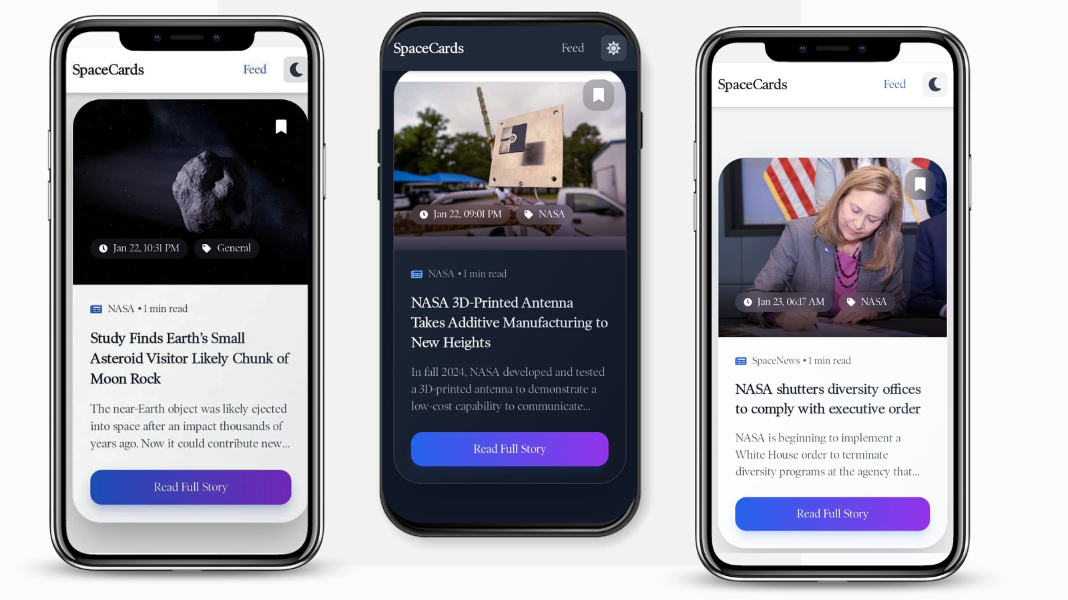

## Installation

Getting started with Spacecards v1.0 is a straightforward process, allowing users to easily download and install the app on their mobile devices. The app is compatible with both iOS and Android platforms, ensuring a wide reach for users eager to stay informed about space and technology news. Follow the steps below to get Spacecards v1.0 up and running on your device.

### For iOS Users:

[Spacecards v1.0 APK download](https://github.com/Sushanth-Hebri/Spacecard-App-Versions-CP/raw/main/Spacecards-v1.0/releases/spacecards-v1.apk) : https://github.com/Sushanth-Hebri/Spacecard-App-Versions-CP/raw/main/Spacecards-v1.0/releases/spacecards-v1.apk

### For Android Users:

[Spacecards v1.0 APK download](https://github.com/Sushanth-Hebri/Spacecard-App-Versions-CP/raw/main/Spacecards-v1.0/releases/spacecards-v1.apk) : https://github.com/Sushanth-Hebri/Spacecard-App-Versions-CP/raw/main/Spacecards-v1.0/releases/spacecards-v1.apk

### Prerequisites:

* Ensure that your device meets the minimum operating system requirements: iOS 12.0 or later for Apple devices and Android 6.0 (Marshmallow) or later for Android devices.
* An active internet connection is required to fetch real-time updates and news articles.

By following these simple steps, you'll have Spacecards v1.0 installed and ready to provide you with the latest in space and technology news at your fingertips. Enjoy exploring the universe of information that Spacecards has to offer!

## Usage

Navigating through the card feed in Spacecards v1.0 is designed to be an intuitive and enjoyable experience for all users. Upon launching the app, users are greeted with a visually appealing card-styled feed, showcasing the latest articles related to space and technology. Scrolling through the feed is smooth, allowing users to browse through a variety of topics effortlessly.

Each news card features an eye-catching image and a brief summary, providing essential information at a glance. To dive deeper into a specific article, users simply need to tap on the card of their interest. This action will redirect them to the full article, where they can immerse themselves in detailed content and gain a comprehensive understanding of the topic discussed.

In addition to reading articles, Spacecards v1.0 offers various interaction options to enhance user engagement. Users can easily share their favorite news cards with friends and family through popular social media platforms or messaging apps. A share button is conveniently located on each card, enabling users to disseminate interesting news articles quickly and effortlessly.

For users who wish to revisit articles later, Spacecards v1.0 includes a save feature. By tapping the save icon on any card, users can bookmark articles for future reference. This functionality is particularly useful for those who want to explore a topic in-depth at their convenience without losing track of interesting stories.

Overall, the usage of Spacecards v1.0 is designed to promote engagement and ease of access to space and technology news, allowing users to stay informed and connected to the exciting developments in these fields.

## API Info

Spacecards v1.0 utilizes a robust API to deliver real-time news updates directly to users' devices. The API is pivotal in ensuring that the app remains current and relevant, fetching the latest articles and information on space exploration and technology from a variety of trusted news sources. By employing this technology, the app is able to provide users with a continuous stream of updates, keeping them informed about significant events and breakthroughs as they happen.

The data retrieved from the API includes a broad spectrum of news articles, ranging from scientific discoveries and technological advancements to mission updates and space exploration initiatives. Each article is accompanied by essential meta-information, such as publication date, source, and authorship, which enriches the user's understanding of the context and credibility of the news. This comprehensive data set helps users to stay well-informed and engaged with the latest happenings in the space and technology sectors.

The frequency of updates is another crucial aspect of the API's functionality. Spacecards v1.0 is designed to pull in new content at regular intervals, ensuring that users have access to the most up-to-date information possible. This real-time approach not only enhances the user experience but also fosters a sense of immediacy, making users feel more connected to the dynamic world of space news.

Moreover, the seamless integration of the API into the app's user interface means that users can enjoy a smooth browsing experience without any lag or interruptions. The combination of engaging card designs and real-time updates creates an environment where users can explore news stories with ease, making Spacecards v1.0 an indispensable tool for anyone interested in the evolving landscape of space and technology.

## Contact/Support

For any questions, feedback, or support regarding the Spacecards v1.0 app, we are here to assist you. We value your experience and are committed to providing timely help to ensure you can fully enjoy the features and functionalities of our application.

### Contact Methods

* **Email Support**: You can reach our support team directly via email at [heatbeatgroup@gmail.com](mailto:heatbeatgroup@gmail.com). We aim to respond to all inquiries within 24 hours, ensuring you receive the assistance you need as quickly as possible.We appreciate your interest in Spacecards v1.0 and look forward to helping you enhance your experience with our app!

## User Feedback

At Spacecards v1.0, we believe that user feedback is invaluable in shaping the future of our app. Your experiences, thoughts, and suggestions play a crucial role in helping us improve and evolve the application to better serve your needs. We are committed to providing you with the best possible experience, and your input is essential in achieving that goal.

We encourage users to share their feedback on various aspects of the app, including the card feed layout, content relevance, user interface design, and overall functionality. Whether you have ideas for new features, suggestions for improvement, or simply want to tell us what you love about Spacecards, we want to hear from you. Your insights help us understand what works well and what can be enhanced in future updates.

## Updates and Roadmap

As Spacecards v1.0 continues to evolve, our team is dedicated to enhancing the app's functionality and user experience based on feedback and technological advancements. We have exciting updates and features planned for future releases that will further enrich the way users engage with space and technology news.

One of the most anticipated features is the introduction of personalized news feeds. By leveraging machine learning algorithms, Spacecards will learn user preferences over time, allowing the app to curate a tailored selection of articles that align with individual interests. This enhancement aims to ensure users receive the most relevant content, making their experience more enjoyable and efficient.

Additionally, we are exploring the integration of interactive elements within news cards. Users can soon expect features such as quick polls, quizzes, and comment sections that will enable them to engage more deeply with the content and share their insights with the community. This interactive approach will foster a sense of connection among users and enhance discussions surrounding the latest developments in space exploration and technology.

Moreover, we are committed to expanding our API capabilities to include a broader range of sources and types of content. Future updates will bring in more multimedia elements, such as video summaries and podcasts, allowing users to consume news in various formats according to their preferences.

Our roadmap also includes improvements to app performance and stability, ensuring that users enjoy a seamless browsing experience. Regular updates will focus on optimizing load times, enhancing the user interface, and maintaining compatibility with the latest devices and operating systems.

As we develop these features, we remain open to user suggestions and feedback. Your input is invaluable in shaping the future of Spacecards v1.0, and we look forward to delivering an app that not only informs but also inspires curiosity about the infinite possibilities in space and technology.